CMPE321

Project 3

Updated Part 1

Ahmet Fırat Gamsız – 2020400180

Yunus Emre Özdemir - 2020400153

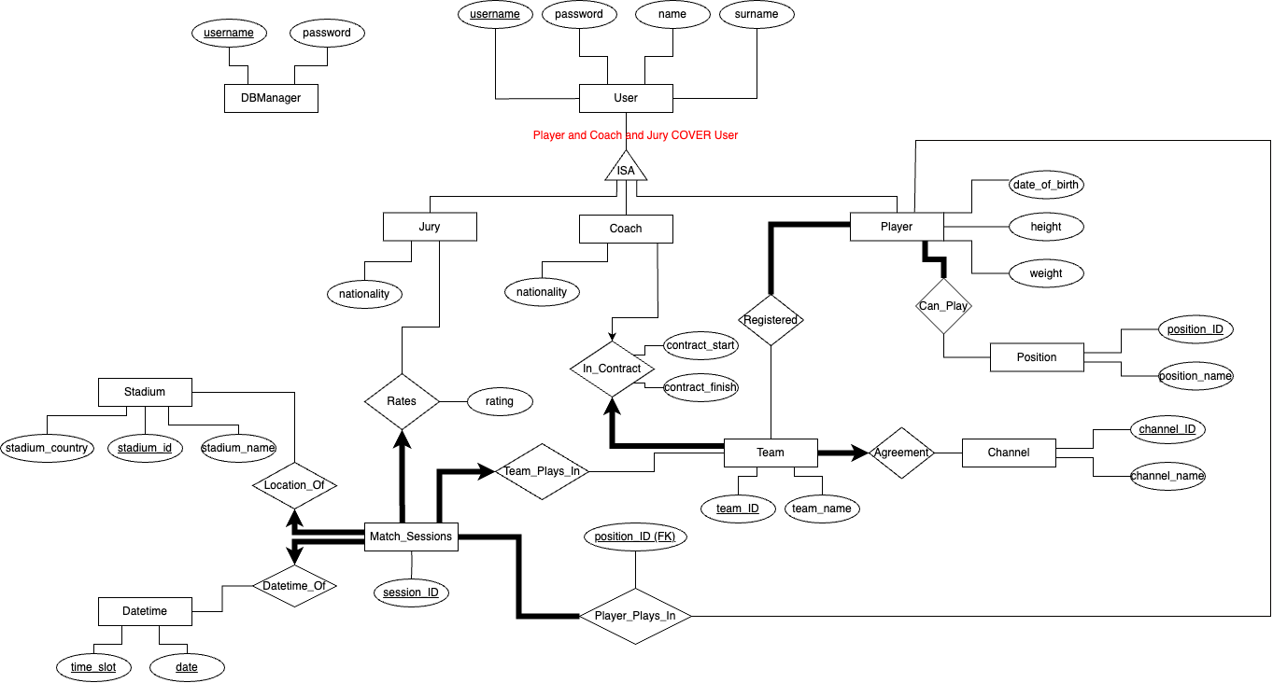



For readability both vertical and horizontal versions of the diagram included

Important: Player and Coach and Jury COVER User